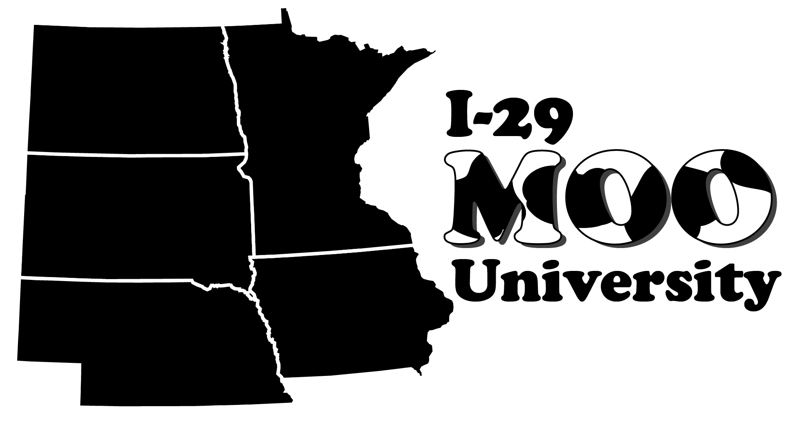

2021-2022 ANNUAL Call for Sponsorship
Annual sponsorship runs from July 1-June 30 each year
Deadline for sponsorship due by June 15, 2021

On behalf of I-29 Moo University, a 5-state collaboration of Extension professionals (IA, MN, SD, NE, ND), we are inviting you to help with sponsorship of our entire year’s activities. We depend on sponsorships from companies such as yours to keep the cost affordable for participants. If you have been a sponsor in the past, we want to thank you for your past support and ask that you continue your sponsorship this year. If you have never been a sponsor, please consider this opportunity to promote your company by supporting these programs for the dairy industry and dairy beef feeders. I-29 Moo University works extensively to reach the growing dairy and dairy beef industries, representing over 896,000 milking cows and nearly 900,000 dairy beef steers on feed. We offer excellent programming throughout the year to meet the ever-changing needs of dairy producers and industry professionals throughout the five-state region addressing timely topics, setting up tours, and connecting progressive ideas.

Historically, in the 5-state region we have offered…
- Three annual in-person programs
- Dairy field days
- Webinars featuring timely dairy topics with sponsor recognition, with over 2,000 live and recorded viewings annually.
- Nearly 800 people view our monthly e-newsletter from locations worldwide, including several foreign countries each month
- Twice monthly podcasts with 2,000 downloads and nearly 1,000 unique listeners

Visit our webpage!
We have a webpage for the dairy industry and dairy beef feeders. Visit us here to see upcoming events and webinars, register for programs, access to recordings and proceedings, plus our current list of sponsors.

Staying responsive to the industry…
We recognize the pandemic has changed how I-29 Moo-University delivers programs as outreach has now gone beyond the five-state region and even internationally! We are currently conducting a needs assessment via an on-line survey. This will help us stay current and relevant to the I-29 dairy industry and dairy beef feeders by providing educational topics in delivery methods most often used by participants.

Foundation Programs: |  | Communication Outreach:
Winter Workshop – January |  | Monthly e-newsletter
Dairy Beef Short Course - March |  | Webpage
Dairy Field Days – July-October |  | Social Media
Webinars – On-demand |  | New releases
Podcasts – Twice monthly |  | Radio Interviews

Sponsorship Deadline: To ensure your company logos are included in marketing materials, sponsorship commitments and company logos are due by June 15, 2021. Commitments and materials that come in after the June 15th deadline will be assessed an addition 10 percent surcharge.

You are the only person receiving this information for your company, so please share this with co-workers who may be responsible for sponsorships in the various regions we do programming.

Your company is invited to participate in one of the following options:

Sponsorship levels: (late fee of 10% will be assessed after the June 15th deadline)
Gold - $2,000
- Your company logo with a link to your website in each monthly e-newsletter
- 1-page advertisement in all event proceedings
- Recognition at in-person events, along with 2-3 minutes elevator speech
- Recognition during each webinar
- Recognition during each podcast
- Recognition on social media promotions
- Opportunity to bring promotional item to distribute during in-person event
- Logo on all promotional materials for each event
- Two (2) registrations and proceedings for each event

Silver - $1,000
- Logo in Silver sponsor collage in the monthly e-newsletter
- ½ page (7.5 x 4.5” horizontal) advertisement in all event proceedings
- Logo on all promotional materials for each event
- Recognition during each webinar
- Recognition on social media promotions
- One (1) registration and proceedings for each event

Bronze - $500
- Logo in the Bronze sponsor collage in the monthly e-newsletter
- Logo on all promotional materials for each event
- Recognition on social media promotions
- Recognition during each webinar

As a sponsor at any level, it is encouraged to help promote and share the monthly I-29 newsletter and company sponsored events with your clientele.

Your financial support is vital and greatly appreciated. If you are interested in being an I-29 Moo University programming sponsor receiving the benefits listed above for July 2021 through June 2022, please confirm your commitment and sponsorship level by June 15, 2021.

Pay by credit card at https://form.jotform.com/4Hregion1/i-29-moo-university-sponsorship.

If you have any questions regarding payment please call Fred Hall at (712) 737-4230 or e-mail fredhall@iastate.edu or Kim Clark at (402) 472-6065 or email kimclark@unl.edu. Thank you for your consideration.

Sincerely,
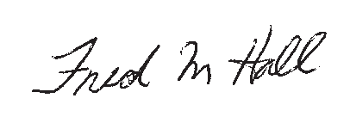
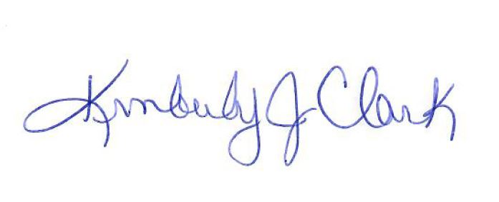
Sponsorship committee members

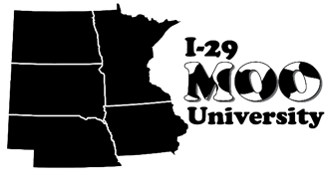
I-29 Moo University
Educating and Ag-vocating for the Future

2021-2022 Annual Sponsorship Invoice Checklist

DATE:

SPONSOR COMPANY NAME:
SPONSOR CONTACT Name:
Phone:
Email:

EMAIL SPONSOR LOGO FOR WEBSITE TO: fredhall@iastate.edu (GOLD SPONSOR LEVEL ONLY)

Sponsorship level | Amount | Choose level  (check box)
Gold | $2,000
Silver | $1,000
Bronze | $500
 | Total:
Payment type (check one): Check Credit card

The I-29 Moo University and the participating Universities: Iowa State University, University of Minnesota, University of Nebraska, North Dakota State University, and South Dakota State University, would like to THANK YOU for being an Annual Sponsor of I-29 Moo University programs.

Please make checks payable to “ISU Extension - I-29” and include a copy of this invoice with your check OR pay by credit card at https://form.jotform.com/4Hregion1/i-29-moo-university-sponsorship

Please mail check and invoice to:
ISU Extension and Outreach, Sioux County
400 Central Ave, NW, Suite 700
Orange City, IA 51041

Learn more about I-29 Moo University at: https://dairy.unl.edu/i-29-moo-university

